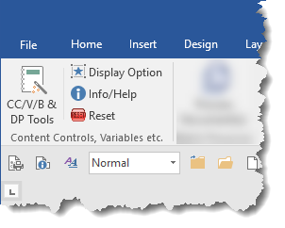

Principle functions are on the Developer Tab of the ribbon

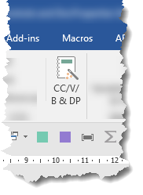
A duplicate of the main button is optionally available on the Insert Tab

